# ABSTRACT

Mentoring is the process whereby an experienced person guides and supports a younger or less experienced person in an educational institution. Mentoring in higher learning institutions helps learners acclimate to new academic topics, increases likelihood of academic support, and reduces weakness. The current practice used by many higher learning institutions for example Strathmore University is that upon joining a mentor is assigned to each student. The student then schedules a session and has a meeting with the mentor. This hinders an effective mentoring process as students lack information on mentoring, difficult to have a follow up on the mentoring sessions, analysis and report on mentoring program.

These challenges can be overcome by developing an online mentoring system. The system allows mentors and mentees to schedule meetings and set milestones that will track the progress of the mentee to ensure confidentiality and provide reports on the mentoring sessions.

The system is however not meant to completely get rid of face-to-face mentoring sessions but to complement the face-to-face mentoring as in some instances people would want to meet their mentor.

An object-oriented approach has been used to develop a system to improve the mentoring process. The approach that has been used is the prototyping framework to ensure the system was developed iteratively.

**Table of Contents**

Title i

Certification ii

Acknowledgement iii

Declaration iv

Abstract i

List of Figures v

List of Abbreviations 6

Chapter 1: Introduction 7

1.1 Background 77

1.2 Problem Statement 8

1.3 Aim 8

1.4 Specific Objectives 8

1.5 Justification 8

1.6 Scope and Limitations 9

1.6.1 Scope 9

1.6.2 Limitations 9

Chapter 2: Literature Review 10

2.1 Introduction 10

2.2 Current Mentoring Systems 10

2.2.1 Strathmore University Mentoring System 10

2.2.2 Elizabeth City State University Mentoring System 10

2.2.3 Mumbai University Student Mentoring and Assessment System 11

2.3 Drawbacks of the current system 11

2.4 Technological solutions to help improve mentoring systems 12

2.5 Conceptual Framework 12

Chapter 3: Research Methodology 14

3.1 Introduction 14

3.2 System Analysis 14

3.2.1 Methods to be used to Gather the Functional and Non-Functional Requirements 14

3.2.2 Proposed Functional and Non-Functional Requirements 14

3.3 Prototyping Methodology 15

3.3.1 Requirement gathering and analysis 15

3.3.2 Quick design 16

3.3.3 Build a prototype 16

3.3.4 Initial user evaluation 16

3.3.5 Refining prototype 16

3.3.6 Implement product and maintenance 16

3.4 Justification of Methodology 17

3.5 System Design 17

3.6 Tools and Techniques 18

3.7 Method to be used to test the proposed system 18

3.8 Domain of Execution 18

3.9 Developed Modules and System Architecture 18

3.10 Ethical Considerations 19

Chapter 4: System Analysis and Design 20

4.1 Introduction 20

4.2 Requirements Gathering 20

4.3 Systems Requirements 20

4.3.1 Functional Requirements 20

4.3.2 Non- Functional Requirements 21

4.4 System Architecture 22

4.5 System Designs 23

4.5.1 Use Case Diagram 23

4.5.2 Class Diagram 25

4.5.3 Sequence Diagram 26

4.5.4 Entity Related Diagram 29

4.5.5 Database Schema 30

Chapter 5: System Implementation and Testing 31

5.1 Introduction 31

5.2 System Implementation 31

5.2.1 Installation Procedure 31

5.2.2 System Manual 32

5.3 System Testing 36

5.3.1 Test Cases 37

5.3.2 Test Results 41

Chapter 6: Conclusions, Recommendations and Future Works 43

6.1 Introduction 43

6.2 Discussion 43

6.3 Conclusion 43

6.4 Recommendation and Future Work 44

References 45

Appendix: Source Code 47

# List of Figures

Figure 1: Conceptual Framework .............................................................................. 15

Figure 2: Prototyping Methodology (Despa, 2014) ................................................... 18

Figure 3: System Architecture ................................................................................... 24

Figure 4: Use Case ..................................................................................................... 25

Figure 5: Class Diagram............................................................................................. 28

Figure 6: General System Diagram ............................................................................ 29

Figure 7:Admin module ............................................................................................. 30

Figure 8: Mentee module ........................................................................................... 30

Figure 9: Mentor Module ........................................................................................... 31

Figure 10: ERD .......................................................................................................... 32

Figure 11;Database Schema ....................................................................................... 33

Figure 12: Cloning snippet ......................................................................................... 34

Figure 13: Clone Snippet ........................................................................................... 35

Figure 14: Xammp installation snippet ...................................................................... 36

Figure 15: Admin dashboard ...................................................................................... 37

Figure 16: Mentor Dashboard .................................................................................... 38

Figure 17:Mentee Dashboard ..................................................................................... 38

# List of Abbreviations

|  |  |
| --- | --- |
| AMS | Academic Module System |
| AJAX | Asynchronous JavaScript and Extensible Markup Language |
| BBIT | Bachelor of Business Information Technology |
| CBIS | Computer-Based Information Systems |
| CSS | Cascading Style Sheet |
| GHz | Giga Hertz |
| GUI | Graphical User Interface |
| HTML | Hyper Text Markup Language |
| IDE | Integrated Development Environment |
| OOAD | Object-Oriented Analysis and Design |
| PHP | Hypertext Pre-processor |
| RAM | Random Access Memory |

# Chapter 1: Introduction

## 1.1 Background

Mentoring is the process whereby an experienced person guides and supports a younger or less experienced person in an educational institution. Mentoring is seen to enhance and retain the strategy for undergraduate education. It is hoped that having a mentoring system will increase the academic achievement of students. (LM Lee, 2010). Having a faculty mentor will ensure the mentees do well in their academic careers and it is easier for them to have a better understanding and relate to the academic progress. This not only encourages the students to do better but also enables them to get help where necessary (JC Johnson, 1999). It is an additional responsibility since successful adaptation of the beginner is represented as demonstration of work quality of the mentor. (Julia Gnezdova, 2018)

The mentoring system used in higher learning institutions is such that upon enrolling one is supposed to be assigned a mentor who will provide guidance. It is dependent on the students to contact their mentor and discuss important issues. This provides a chance for students to grow and reach their maximum potential. (Mentoring at Strathmore University, 2020) Most of the students do not contact their mentor and for those who contact their mentor they are not able to have an indepth conversation with their mentor and they rarely meet their mentor. This restricts the student from growing fully and reaching their maximum potential. The students also do not extensively discuss their academic performance with their mentor due to several reasons such as being shy, antisocial, or having self-esteem issues. This probes one to search for answers online rather than receive guidance from a professional.

With increasing globalization and technological advances, mentoring dynamics are being reshaped by new forms of work, technology and learning. (Arthur Maitland, 2011)

Current advancements in technology, mentoring can be improved whereby the mentee does not have to physically meet their mentor instead, they can just login to a system and have a session with the mentor. The mentor can set milestones which will help improve the character of the student and grow on all levels. The online system is more flexible to individual schedules. There are certain issues that people would be more open to discussing on chat rather than face-to-face for example a personal matter they need advice on and would be embarrassed to speak about faceto-face.

## 1.2 Problem Statement

Traditional mentoring systems lacks an effective mentoring process as students lack information on mentoring, have difficulty on following up on mentoring sessions. The solution seeks to develop a web-based mentoring platform that will allow time flexibility by allowing students and mentors to be able to schedule meetings, track the progress of the mentee, provide reports on the mentoring sessions, allow students to login to system.

## 1.3 Aim

The projected aimed to develop a web-based mentoring system that will be implemented in higher learning institutions through the university administration to provide a step by step guidance to the students.

## 1.4 Specific Objectives

1. To analyse existing mentoring system.
2. To design a mentoring system. iii. To develop a web-based mentoring system that will help improve the mentoring process

iv. To test the mentoring system

## 1.5 Justification

This is an important system and will come to use not only during the time of this pandemic but also during the normal day to day activities. The developed system helps to improve the communication between mentors and mentees as well as build the character and help the student gain full potential.

The developed system allows mentors and mentees have live chat sessions and also discuss about the student grades to analyse the trend in their grades. The analysis of these trends will provide information for the mentee on where he/she thinks the student should improve. The system also provides a clear platform for tracking the progress of the mentee by checking off the tasks provided for them.

## 1.6 Scope and Limitations

### 1.6.1 Scope

The project is expected to mainly major on allowing mentors to keep track of the mentees progress and conduct mentoring sessions online and provide materials on mentoring. The proposed system should educate students on mentoring and try to find out what students are going through and address them appropriately.

### 1.6.2 Limitations

The restricting factor to this system is limited internet access in remote areas and the testing cost which is also a challenge as well as testing it amid the pandemic which will be difficult as it is important to test a system. The factors can affect the quality of the system.

# Chapter 2: Literature Review

## 2.1 Introduction

The focus of this chapter is to look at the documentation of the current systems being used in mentoring. It will help in looking at previous research on the systems and familiarize with the methodology used, look at the flaws of the previous system and the impacts they have so that they can be improved on.

## 2.2 Current Mentoring Systems

Most higher education institutions use manual approach in mentoring while a few institutions use automated approach. Below are sample systems that apply a manual, automated and a case study of mentorship systems.

### 2.2.1 Strathmore University Mentoring System

Mentoring in Strathmore University is provided at the beginning of the first year with an aim of creating an all rounded citizen with a new sense of maturity able to bring changes to our society and assisting students transition from high school to university environment. The University’s website provides information like; Why mentoring, Who is a Strathmore University mentor, the aims of mentoring, how many times you should meet your mentor, what you should discuss with your mentor and a breakdown of the mentoring agenda based on each year of your study in Strathmore. The university allocates a mentor to each student. The student should reach out to the mentor and have sessions to discuss various topics. By the school requirements a student should meet their mentor at least three times a semester. This is done to ensure efficient and effective flow of the program. (Mentoring at Strathmore University, 2020)

The automized system is available to the mentors only where they can log in the system and access background information on students and provide details on when they have interacted with their mentees. The system provides a list of all mentees that a mentor is assigned to.

### 

### 2.2.2 Elizabeth City State University Mentoring System

Elizabeth City State University uses an E-Mentoring program to provide mentoring services to its students by outsourcing the system from a mentoring software called Chronus. This is a software whose focus is mentoring based on aspects such as career, internship, and peer mentoring among others. The system allows mentors to register as e-mentors and mentees as e-mentees to facilitate a constructive and engaging e-mentoring platform. (Elizabeth City State University, 2020)

### 2.2.3 Mumbai University Student Mentoring and Assessment System

According to the case study conducted in Mumbai University, a Student Mentoring and Assessment (SMA) software was to be developed which would store the academic and extracurricular performance of each student in a central computer system over time with a unique identification number. The main objective of the project is to develop a web-based system to manage mentoring. The system should maintain the students biographical status and academic information in a secure accessible system and assign a mentor to every student who will maintain the record of the overall student performance, the mentee will be able to key in their personal information like contact information, academic details and extra-curricular details. The mentor will also be able to contact the parents in case there is an issue. (Mayuri Kini, 2014)

## 2.3 Drawbacks of the current system

Mentoring in higher education has occurred either informally or as a planned program where mentees are matched to seniors such as lecturers. There is little done to enhance a more interactive and collaborative atmosphere. There lacks a system to gauge the effectiveness of the sessions. (Ann Darwin, 2009)

Across all Higher Educational mentoring settings, one of the main challenges reflects the academic, social and personal boundaries between mentor and mentee. It is mostly the mentee who reach out to the mentors making it a challenge for mentors to assess when the mentees might need some advice or are in a depressing situation. Most systems have not addressed this issue. (Vidya V. Haran, 2019)

Quite several mentoring systems focus on bridging the gap between one educational level to another like from undergraduate to a masters or the transition from campus to industrial life. Less focus is put on a system that would facilitate this. (Elizabeth City State University, 2020)

## 2.4 Technological solutions to help improve mentoring systems

To be able to counter some of the problems stated above, an online mentorship program will be implemented. An online mentoring program, Tracking Canada’s Past (TCP) that was implemented in three high schools in British Columbia, Canada, in 2003 investigated the contributors to a successful online educational program. The researchers investigated the application of online mentoring using the knowledge forum software where the students could share and discuss their research with their mentors and fellow students. They were 72 students with 16 online mentors where each mentor had approximately 5 to 11 students. Through pre and post program surveys, interviews, background data on the students and expectations of mentoring the findings indicated a successful mentoring program based on the questions asked by mentors. The online materials also helped the mentoring process. (Asgari, 2010)

A web-based system will allow mentors and mentees, despite having heavy workload, lack of time or to discuss matters that are rather sensitive, to freely communicate whenever they want. The system will try implement a safe environment, set milestones for students, provide materials that will help improving the mental health of students and help them grow all round.

## 2.5 Conceptual Framework

The proposed function of the system will be as follows, the mentor will have to login in as an administrator and the mentee as a user. If the credentials are not accepted, they will be prompt to repeat the process. Once the credentials are approved the student will see the homepage, will be able to start a session with the mentor and input their grades, hobbies, among others. The mentor will be able to set milestones and post materials that will help the mentee in various ways.

The information provided by the users is stored in the database and retrieved upon requirement.

The users access the system using the web-based admin panel via a data connection.

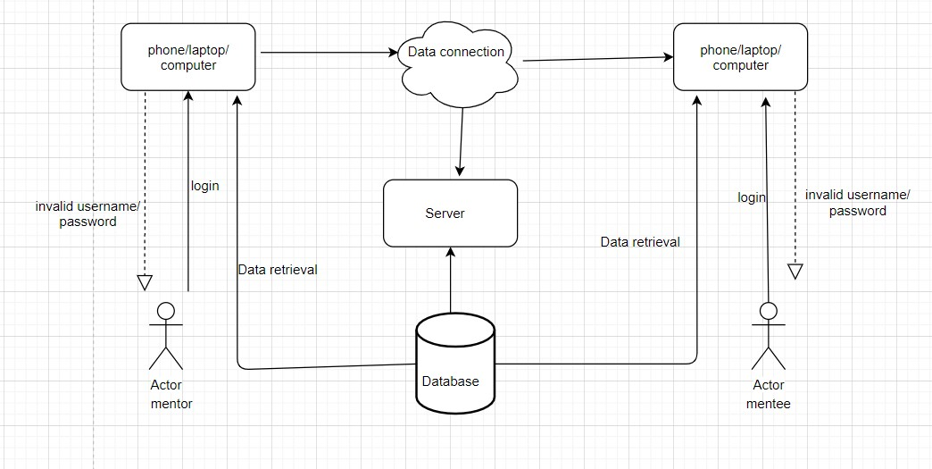

Figure 1: Conceptual Framework

# Chapter 3: Research Methodology

## 3.1 Introduction

System development is the approach that is used to systematically form, plan and to control the development process of a system. (Ngbagaro, 2016)It is crucial in that it prepares you for any issues that will come across.

The methodology best suited for the developed system is prototyping. This is because prototyping allows you to build a prototype which you can later use for testing. The steps that are involved in prototyping are requirements gathering and analysis, system design, system architecture, testing and implementation which has been discussed in detail.

## 3.2 System Analysis

The analysis approach that was used in developing the system is Object-Oriented Analysis and Design (OOAD). This specific approach has been chosen as it divides the project into smaller parts which is easy to handle. This approach also allows for re-use of code which saves time and cost as well as helping in improving the quality of the system.

### 3.2.1 Methods to be used to Gather the Functional and Non-Functional Requirements

The techniques used to list the functional and non-functional requirements are to review the existing Computer-Based Information Systems (CBIS) and use questinnaires.

### 3.2.2 Proposed Functional and Non-Functional Requirements

**3.2.2.1 Functional Requirements**

Some of the functional requirements the system should have are:

1. Authentication

The users of the system should be able to login in order to access the system. This includes the students, admin and mentors.

1. Administrative functions

The admin has privileges such as adding a mentor to the system, adding a student to the system and accessing the dashboard.

1. Mentoring sessions

The system should ensure students are able to chat with mentors and discuss their issues.

1. Request for meeting

The mentees should be able to request for a meeting at any time they want to have a session with their mentor.

1. Provide information on mentoring

The system is able to provide materials on mentoring like what mentoring is, what to expect from mentoring and what you should discuss with your mentoring.

**3.2.2.2 Non-Functional Requirements**

Some of the non-functional requirements the system should have are:

* 1. Usability

The system should be user friendly.

* 1. Security

It is important for a system to be secure and protect user information. iii. Accuracy

The proposed system should be able to present correct data that the user has provided without corrupting it in any way. iv. Performance

The system should be responsive and less resource intensive to improve the efficiency of the system. It should not take long for the user to access the system.

## 3.3 Prototyping Methodology

Prototyping methodology is a framework that is used in system development where “the developer presents the user with a series of rough approximations (or prototypes) of the computer system”. (Burns & Dennis, 1985)

### 3.3.1 Requirement gathering and analysis

This is the first stage of prototyping in which the requirements of the system are defined. In this stage, a use case diagram was developed to describe the interaction of the user and the system and to identify their system needs. Potential users were also interviewed in order to know their expectations.

### 3.3.2 Quick design

In this stage the classes, attributes, methods, and structures that were identified during the analysis phase were designed and refined. This phase also identifies additional classes or objects that were used to support the implementation of the requirements. This stage helps in making the prototype of the proposed system and also enables the users understand what the prototype will look like.

### 3.3.3 Build a prototype

This stage takes place after the system requirements has been identified where a prototype was built which is a small working model of the actual system. The prototype was built to understand how the user requirements were implemented. The prototype was built from the information that was gathered from the users. Some factors that were considered when developing the prototype are user requirements and cost incurred while developing the system.

### 3.3.4 Initial user evaluation

This stage is an iterative process as it relies on the feedback from the users after which the prototype will be refined and depending on the feedback it is accepted or changes will be made and the same process will be repeated.

### 3.3.5 Refining prototype

This stage is iterative as well as it works with the previous step. For this stage to be complete the user requirements have to be met. The developer works on the feedback received from the users until the user is satisfied.

### 3.3.6 Implement product and maintenance

After the final system was developed it was tested. The system is then distributed to production. The system then goes to maintenance to avert failure. (Tozer, 2003)

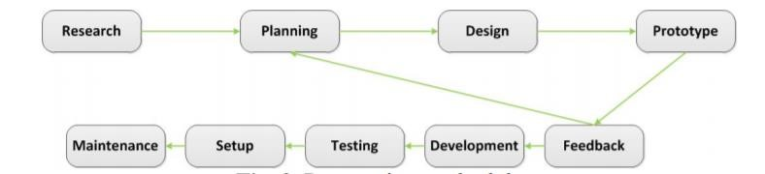

Figure 2: Prototyping Methodology (Despa, 2014)

**3.4 Justification of Methodology**

According to Jane E Tozer in her periodic journal, prototyping methodology is by far the simplest approach to use where system testing and user participation is involved, “It is common these days to build prototype systems before delivering an expensive system. However, there can be much conflict between developer and user about timescales, adjustments and a deliverable end result. One UK software house shows how conflicts can be avoided through clearly defined project roles and adoption of a workable methodology.” (Tozer, 2003)

Prototyping is best suited for the developed system as users can point out the features that they don’t like about an existing system or point out the missing feature in the system.

## 3.5 System Design

The developed system used the OOAD method where the following diagrams will be drawn:

1. Use case diagram

Use case diagram is the graphic representation that is used to show the interactions of different elements of the system like the user and different use cases in which the user is involved. This will be used in the interaction between different elements in the system.

1. Class diagrams

Class diagram will be used to describe the attributes and operations of the class as well as the constraints in the system. It will show the system’s class, attributes, relationships and methods.

1. Sequence diagrams

Sequence diagram outlines how and the order in which objects in a system function.

1. Database schema

Database schema is the structure of the database that is presented in a logical format which defines how data is organized and the association of relations.

1. GUI mock-ups

GUI mock-ups is used to show different graphical user interfaces that are to be created like forms.

## 3.6 Tools and Techniques

The test environment for the developed application was tested under both hardware and software specifications that are windows 10, 64-bit operating system, Intel Core i7-8565U CPU @ 1.80GHz, 8.00 GB RAM and Apache HTTP server

The development tools that were used are Php storm integrated development environment, MySQL relational database management system to help maintain the database in the system. PHP programming language together with Laravel web framework.

The programming languages used are PHP, JavaScript, AJAX and JQUERY. To bring out the design element in the system Hyper Text Mark-up Language (HTML) and Cascading Style Sheet (CSS).

## 3.7 Method to be used to test the proposed system

They were two methods used to test the system, usability testing and unit testing. Usability testing was done to determine if the design and aspects of the system coincide with the necessary workflows while unit testing was done to ensure the system units are functional and work according to the system requirements.

## 3.8 Domain of Execution

The approach used to execute the developed system is web-based. A web-based system broadens the number of people that will use the system as there are very few requirements to access the system like availability of basic internet connection. One does not need to download, update and manage the system and being a web-based system, it is up to date.

## 3.9 Developed Modules and System Architecture

The developed system enables mentors and mentees to meet at any time and be free to discuss anything. A web-based system has been used to ensure this. The students select a mentor. The developed modules are the authentication module which validate the information provided by the users. The mentor’s module where the mentor is able to login and access student information.

There is a mentee’s module where they are able to have sessions with their mentor and access materials and a report module where you can get reports on the progress of the student.

## 3.10 Ethical Considerations

For any research study it is crucial to ensure ethical considerations have been put in place. The proposed system will follow the following ethical practices:

1. Voluntary participation of respondents

It is crucial for participants to participate in the research by free will and can withdraw from it at any time.

1. Proper use of language

No offensive language will be used in the system. iii. Anonymity

Anonymity of participants should be ensured by the researcher. iv. Acknowledgement

The work of other authors should be acknowledged by citing and referencing.

v. Safety of participants

The study should ensure there is no physical or psychological harm to the participants.

# CHAPTER 4: SYSTEM ANALYSIS AND DESIGN

## 4.1 Introduction

The aim of this chapter is to highlight the methods and techniques used to gather the system requirements. It will focus on the system requirements stated in chapter 3 and have a presentation of the system architecture to illustrate how the different modules interact with each other. This will also be backed up by the design diagrams.

## 4.2 Requirements Gathering

The methods that were used in requirement gathering are use of questionnaire and observation.

The first method was use of observation. When we had classes in Strathmore before the pandemic I had observed that the standard procedure for meeting a mentor is emailing the mentor and requesting for a meeting. The mentor would provide a designated location where they would meet. However, many students did not meet their mentors or reach out to them. With the pandemic it became even harder to meet the mentor in any way because of the restrictions.

The second method that was used was questionnaires. The questionnaire was drafted using google forms and sent to different people via email to fill. The results from the questionnaire underwent qualitative and quantitative analysis to derive the functional and non-functional requirements.

## 4.3 Systems Requirements

### 4.3.1 Functional Requirements

|  |  |
| --- | --- |
| **Requirement ID** | **Requirement Description** |
| FRQ1 | The system should allow mentees to select a mentor |
| FRQ2 | The system should allow mentees to request for meetings |
| FRQ3 | The system should allow admins and mentors to post mentoring materials |
| FRQ4 | The system should allow the mentors and mentees to have a session via a chat stream |
| FRQ5 | The system should allow the admin the view reports. |
| FRQ6 | The users should be able to login to the systems |

### 4.3.2 Non- Functional Requirements

|  |  |  |
| --- | --- | --- |
| **Requirement ID** | **Requirement Category** | **Requirement Description** |
| NFRQ1 | Usability | The system should notify the mentor when a meeting request is sent |
| NFRQ2 | Usability | The system should notify the mentee on whether the request is accepted or the mentor has asked for reschedule. |
| NFRQ3 | Usability | The system should be easy to use and navigate for end users. |
| NFRQ4 | Performance | The system should cater for the requests of the users at optimal speed |
| NFRQ5 | Supportability | The system should be able to run on multiple devices without crashing. |

## 4.4 System Architecture

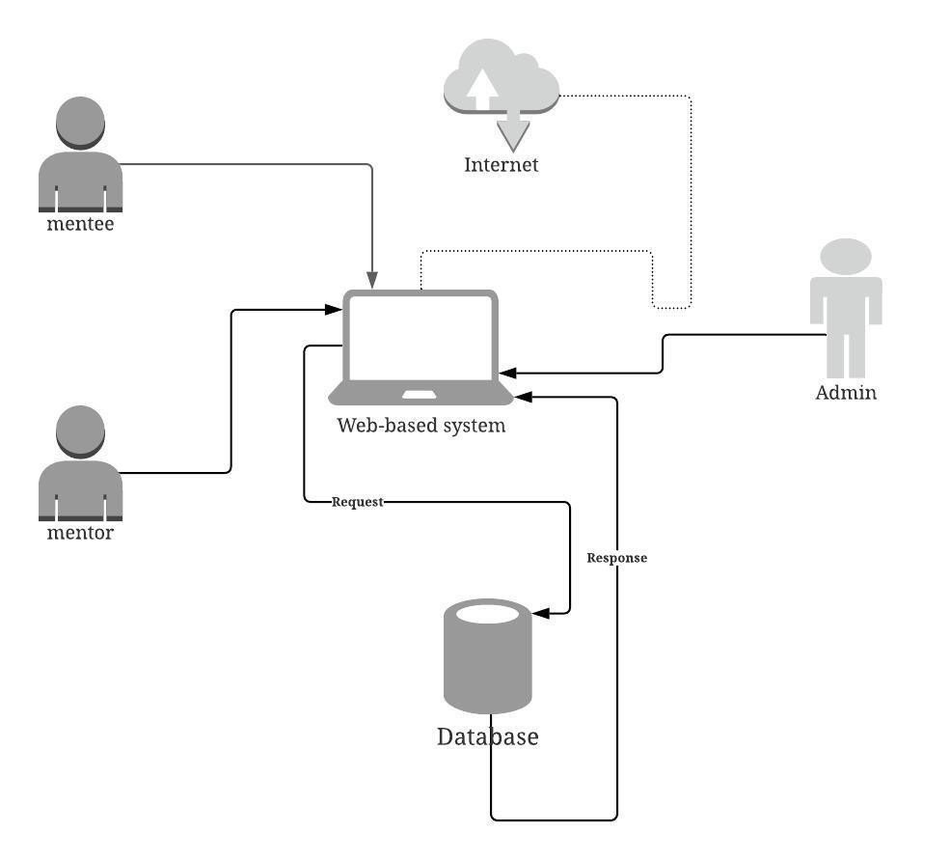

Figure 3: System Architecture

## 4.5 SYSTEM DESIGNS

### 4.5.1 Use Case Diagram

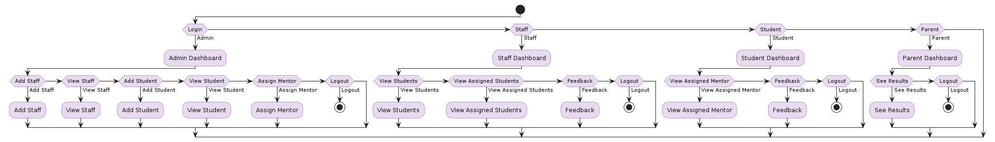

Figure 4: Use Case

|  |  |
| --- | --- |
| Name | Online mentoring system |

|  |  |
| --- | --- |
| Description | An online mentoring system that allows mentors and mentees have interactions, access materials and store all details. |
| Primary Actors | Mentor  Mentee |
| Secondary Actors | Administrator |
| Pre-Conditions | Since the domain of execution is web-based therefore the system must be connected to the internet.  All mentors and mentees should have access to the system.  The admin should have access to the system.  The mentor should access the mentor’s information. |
| Post Conditions | The users should be able to log out.  The system should be able to store data from previous sessions.  The sessions should end once the users have logout. |
| Main Flow | **Admin**  The admin should be able to add all users to the system.  The admin should be able to access reports. The admin should be able to add or remove mentors and mentees from the system.    **Mentors**  The mentors should be able to login to the system.  The mentors should be able to start sessions with mentees. |
|  | The mentors should be able to provide mentoring materials to their mentees.  The mentors should be able to have access to mentees background information.    **Mentees**  The mentees should be able to login to the system.  The mentees should be able to access materials on mentoring.  The mentees should be able to request for meetings. |
| Alternate Courses | For incorrect credentials, the system should be able to validate the login and provide an error message.  In case the users forget their password, they should be able to reset it. |

### 4.5.2 Class Diagram

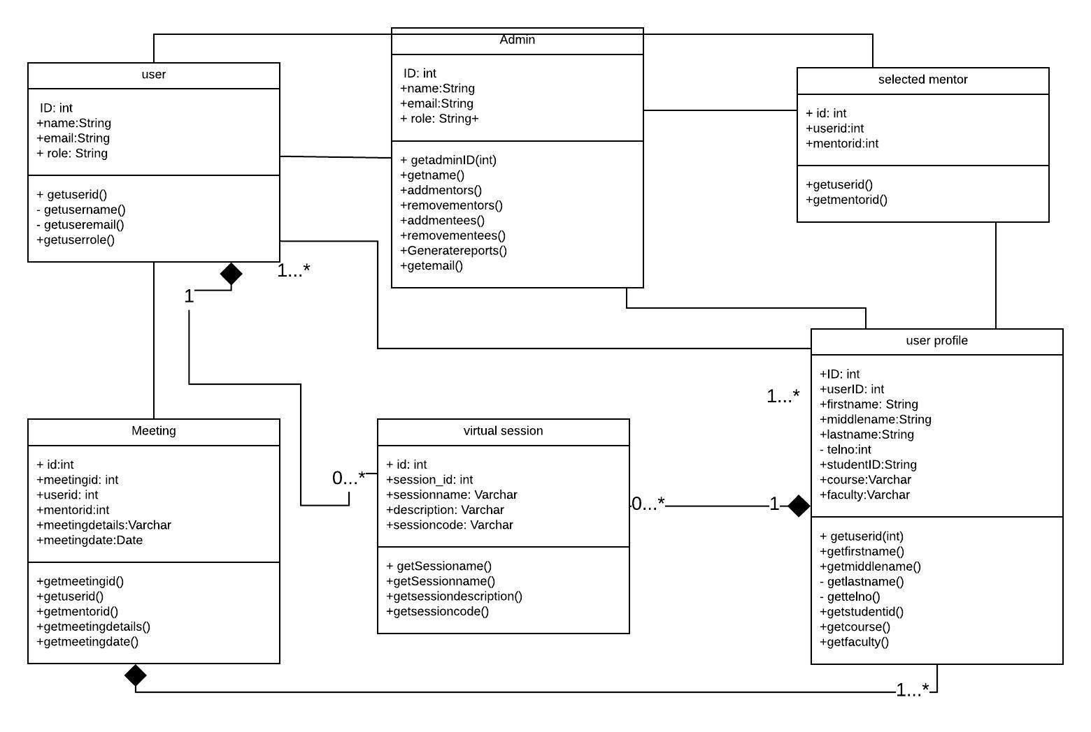

Figure 5: Class Diagram

### *4.5.3 Sequence Diagram*

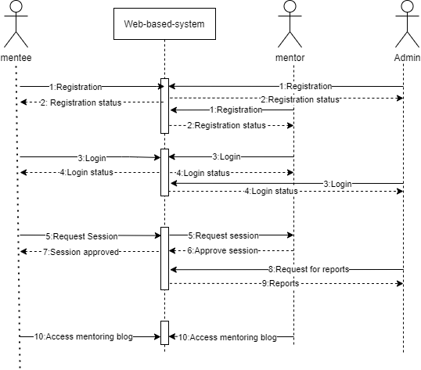

Figure 6: General System Diagram

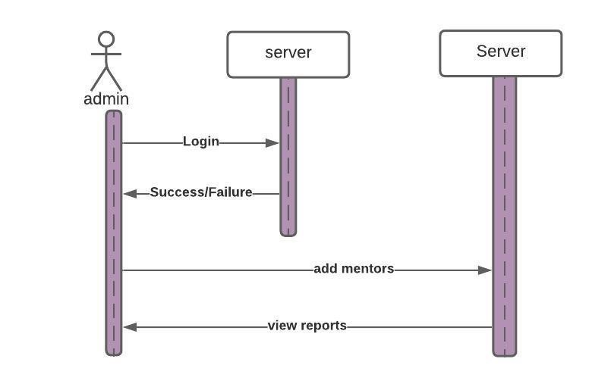

Figure 7:Admin module

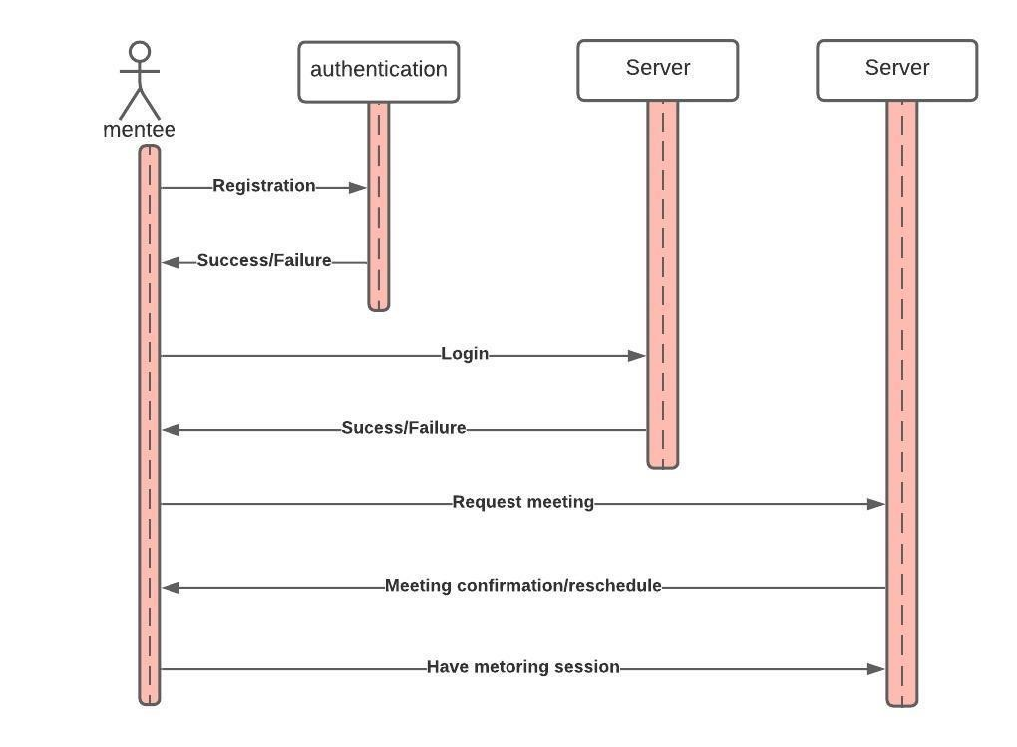

Figure 8: Mentee module

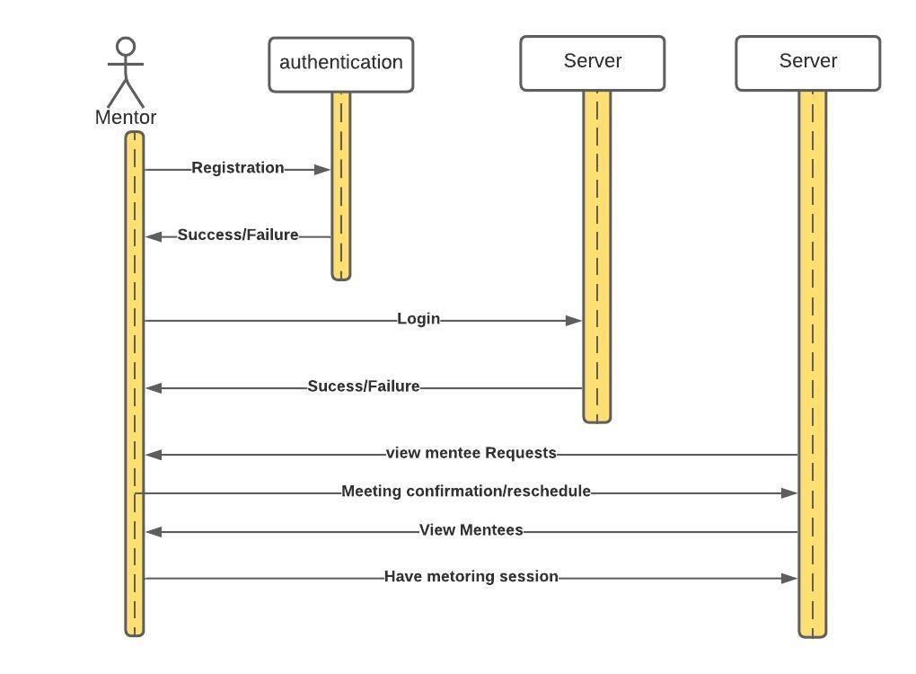

Figure 9: Mentor Module

### *4.5.4 Entity Related Diagram*

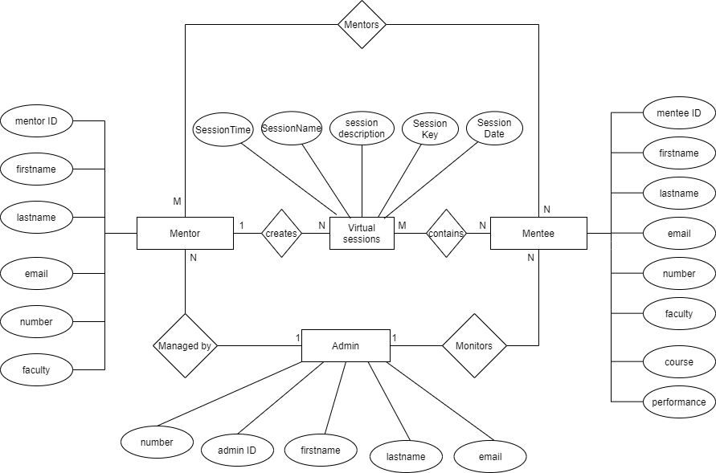

Figure 10: ERD

### *4.5.5 Database Schema*

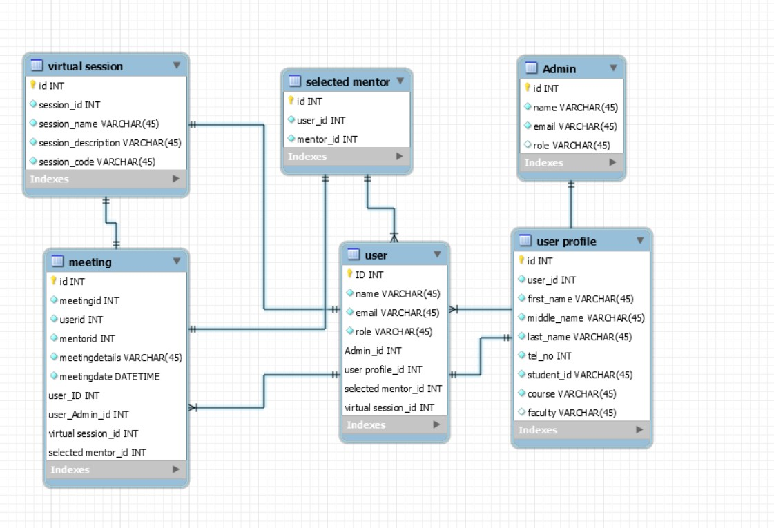

Figure 11;Database Schema

# CHAPTER 5: SYSTEM IMPLEMENTATION AND TESTING

## 5.1 Introduction

This chapter focuses on describing how the system was developed. It will cover what the system entails and the purposes of the different sections that the system has. This chapter will also entail testing different modules of the system. The aim of testing the system is to detect any errors and fix them before the system is fully implemented to ensure ease of use. It will also test to see if the different requirements of the system are met.

## 5.2 System Implementation

This part will focus on how the system works and the steps that the user will follow in order to access the system.

### 5.2.1 Installation Procedure

This section will explain the steps that the user will take in order to install and set up the system. i. The user can download the project as a zip folder or can clone it by copying the URL.

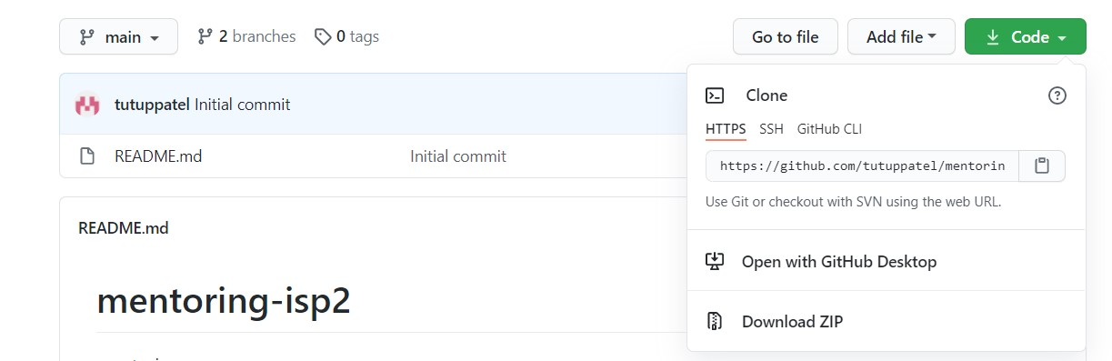

Figure 12: Cloning snippet

1. You go to the terminal of your choice and clone the project to the directory of your choice.

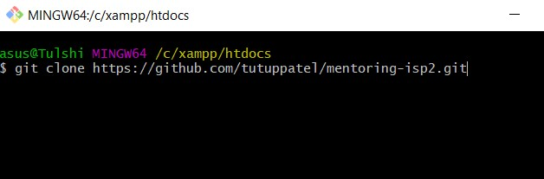

Figure 13: Clone Snippet

1. You then run the following commands one by one to ensure the modules and libraries that keep it running are in place.

-**Composer update -npm install.**

**-npm run dev.**

**-composer require larasocket-driver -** **npm i laravel-echo larasocket-js -npm run dev -php artisan migrate:fresh -php artisan db:seed -php artisan key:generate**

**-**Lastly you run **php artisan serve** to serve the project and you can access the system with the URL provided in the terminal.

iv. The command **php artisan db:seed** gives you dummy data to access the mentor and admin accounts, to get a mentee to register through the sign-up.

### 5.2.2 System Manual

The system which is an online mentoring system has been developed to meet the needs of mentees and mentors and to be able to carry out sessions on the web. It is only accessible to users who have created accounts and have access to stable internet connection.

**5.2.2.1 Pre-setup**

1. Download XAMPP from the internet. Go t[o https://www.apachefriends.org/index.html](https://www.apachefriends.org/index.html) and select the installer for your specific Operating system.
2. Select the downloaded file and this will open the XAMPP setup window, you many have to click OK on a warning if you have a User Account Control activated on your computer. iii. You leave the default options that have been selected and click next

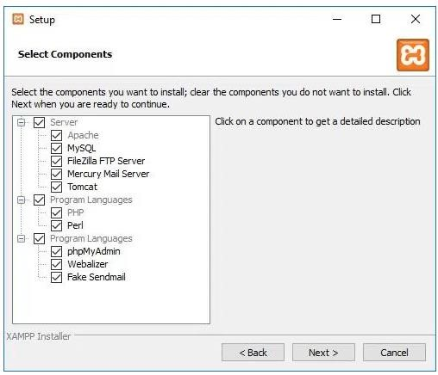

Figure 14: Xammp installation snippet

1. Use the default folder location to install the software and click next. v. Once the Xampp setup wizard is completed click the Finish button.

**5.2.2.2 Getting Started**

i.After you have followed the steps stated in the installation procedure, you have to access the URL printed in the terminal. Mostly the URL is [http://127.0.0.1:8000,](http://127.0.0.1:8000/) though it may vary depending on the ports.

ii.You then use the dummy data produced by the **php artisan db:seed** command to access the admin dashboard. The email can be found in the database while the default password is “password”, once you log in successfully, you can have an overview of the systems and various functionality available to the admin.

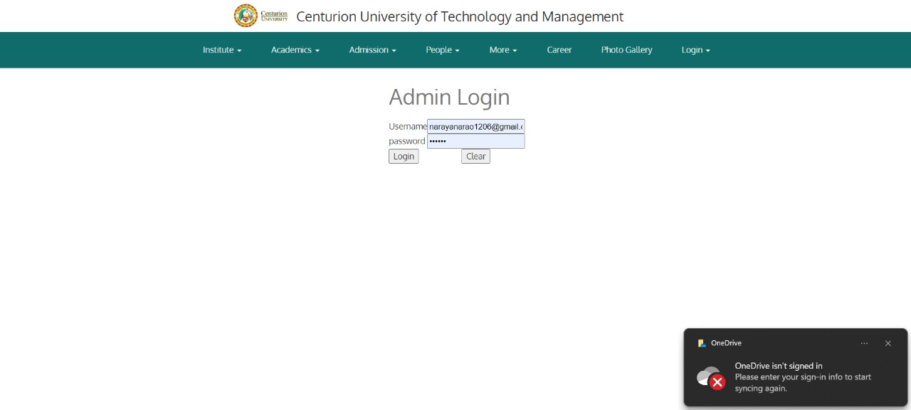

Figure 15: Admin dashboard iii.To access the mentor’s dashboard you can use the data in the database to access the email, and the password is “password” by default. Once you successfully log in you can look at the list of mentees, check session requests, add a blog and start a mentoring session.

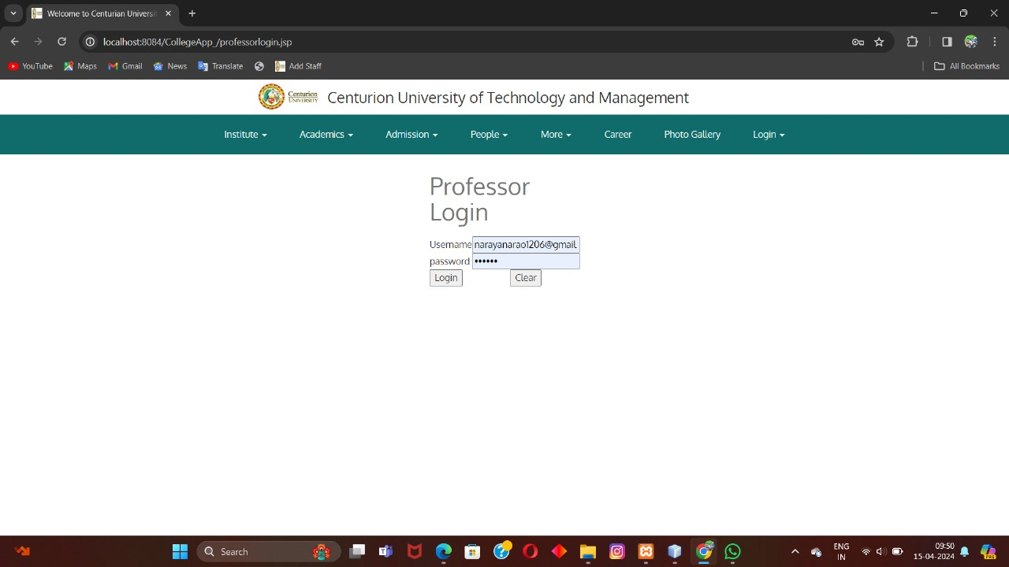

Figure 16: Mentor Dashboard

iv.To sign in as a mentee you will need to fill in your details in the registration page and from there you will log in the system to access the dashboard with the functionalities.

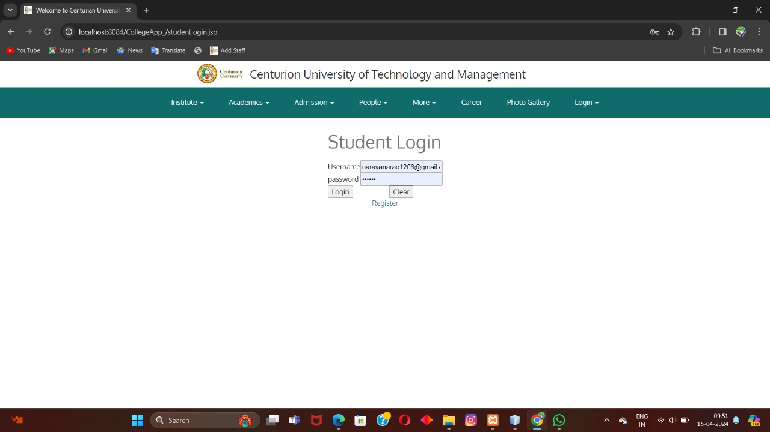

Figure 17:Mentee Dashboard

## 5.3 System Testing

The focus of this section is on what the system does and if it succeeds on the different functionalities as stated in the functional and non-functional requirements. This section will also detect system failures and classify each test according to priority.

### 5.3.1 Test Cases

|  |  |  |  |  |  |
| --- | --- | --- | --- | --- | --- |
| **Test**  **ID** | **Requirement**  **ID** | **Inspection check** | **Preconditions** | **Test Data** | **Priority**  **Level** |
| **T1** | FRQ1 | Does the system allow the admin to sign up and save the data to the database? | The admin should be able to fill in the sign in form and submit it | Email:admin@gmail.com  Password: password | High |
| **T2** | FRQ2 | Does the system allow the admin to view the mentors in the system? | There should be a list of mentors and mentees in the system. | Mentor1@gmail,com  Tulshi.patel@strathmore.edu | low |
| **T3** | FRQ3 | Does the system allow admins to add | The admin should be able to add admins to the system. | Email: mentor1@gmail | High |

|  |  |  |  |  |  |
| --- | --- | --- | --- | --- | --- |
|  |  | mentors to the system? |  |  |  |
| **T4** | FRQ4 | Does the system allow mentors to login and save the data to the database ? | The mentor should be able to fill in the login only if they have been added by  the admin | Email: mentor1@gmail.com  Password: password | High |
| **T5** | FRQ5 | Does the system allow mentors to view session requests sent by the mentees? | The mentee should first send a request to have a session with the mentor | Mentee name: Edalia Meeting details: could we please meet at 2pm. I am depressed.  Preferred date: 2021-01-28  Status: Accept or  Reschedule | High |
| **T6** | FRQ6 | Can the mentor accept or reschedule the request and give another time and date to the mentee? | The mentee should first send a request to have a session with the mentor | The mentor accepts the request and if he selects the reschedule button he is able to give an alternative time and date for the meeting in the form of a text and send it to the mentee | medium |
| **T7** | FRQ7 | Does the system | The mentee should be | Name: Tulshi | High |

|  |  |  |  |  |  |
| --- | --- | --- | --- | --- | --- |
|  |  | allow the mentee to  fill in the sign up form? | able to fill in the sign up form and submit it | Email:  Tulshi.patel@strathmore.edu  Password: password  Confirm password: password  Submit |  |
| **T8** | FRQ8 | Does the system allow the mentee to login? | The mentee should be able to login successfully provided the credentials are right | Email:  Tulshi.patel@strathmore.edu  Password: password | High |
| **T9** | FRQ9 | Does the system allow the mentee to select a mentor? | Upon  registration  the mentee should  select a  mentor from the list of mentors provided | The mentee selected mentor2 | Medium |
| **T10** | FRQ10 | Does the system allow the mentee to request for a session? | The mentee should be able to request for a session  from the mentor by  inputting the meeting | Meeting details: could we meet at 2 pm. I am feeling anxious.  Meeting date: 2021-01-28 | Medium |
|  |  |  | details and meeting date |  |  |
| **T11** | FRQ11 | Does the system allow a chat session between the mentor and mentee? | The mentee should request for a session and mentor to accept the request | Sending messages |  |

### 5.3.2 Test Results

|  |  |  |  |  |
| --- | --- | --- | --- | --- |
| **Test ID** | **Expected**  **Result** | **Actual Result** | **Status** | **Remarks** |
| T1 | The system should allow the mentee to request for a  session | The system allows the mentee to fill in details and select a date in order to have a session. | **Pass** | The test was carried out successfully and the results were as expected. |
| T2 | The system should allow mentors to view the request and either accept or reschedule the  session | The system allowed the mentor to accept the request and also allowed the mentor to  reschedule  giving the | **Pass** | The test was carried out successfully and the results were as expected. |
|  |  | mentee a day and time when they can have a session. |  |  |
| T3 | The system should allow the mentee to select a mentor of  choice | The mentee can select any mentor based on the list provided upon login | **Pass** | The test was carried out successfully and the results were as expected. |
| T4 | The system should have a feedback area | The system has no feedback area | **Fail** | This was not implemented however it will be added in the recommendations for future work |

# Chapter 6: Conclusions, Recommendations and Future Works

## 6.1 Introduction

The main focus of this system is to discuss the objectives set and challenges that were faced while developing the system. It also talks about the extent to which the system solved the issues that were discussed. The chapter will also discuss the recommendations and future works of the current system.

## 6.2 Discussion

In chapter two we talked about the process of meeting your mentor by emailing them and going to meet them in school hours at a designated location. This however had some limitations that the system that has been developed has tried solving.

The system that has been developed allows users to request for sessions and have live chat sessions with their mentors at their own comfort and at flexible times that solves the issues related to time consumption, disruption of classes and inconvenience. The developed system also provides blogs that educate mentees and guide them throughout.

The developed system also has an admin module that adds mentors to the system. The admin module is also able to monitor both mentors and mentees. The admin is also able to generate reports.

## 6.3 Conclusion

Mentoring is an important aspect in everyone’s life. It helps one talk to someone about their problems as well as get a guide on how to go about a situation. However, some people shy off speaking about their issues to someone in person.

The system that has been developed will give mentees the chance to be in touch with their mentors regardless of their location. It is also supposed to encourage students through the blogs that mentors post.

This system will however need the user to have a stable internet connection in order to have their sessions. The mentoring program will strictly apply to one university and not inter university.

## 6.4 Recommendation and Future Work

They are many suggestions and ways for improving a mentoring system. The system that is developed is also among one of the solutions that will help improving the mentoring process it however has its limitations just like any other system. The limitations include one must have internet connection to access the system and it is limited to one university. These are just some of the limitations. Since the objective of the system is to provide quality mentoring sessions to students, the system plans to add more features that will make the system be available offline and to develop a mobile application as well as try to connect it to the academic modules of the university.

**REFERENCES**

1. Ann Darwin, E. P. (2009, March 11). Higher Education Research & Developement. *Mentoring circles in higher education, 28*(2), 125-136. Retrieved from https://doi.org/10.1080/07294360902725017
2. Arthur Maitland, P. T. (2011). In *Future Work: How Businesses Can Adapt and Thrive In The New World of Work.* London: Palgrave Macmillan.
3. Asgari, M. (2010, March 1). Asian Association of Open Universities Journal. *STUDENTS' EVALUATION OF SUCCESS IN AN ONLINE MENTORING PROGRAM*, 1-9. Retrieved from https://www.emerald.com/insight/content/doi/10.1108/AAOUJ-05-01-2010B001/full/pdf?title=students-evaluation-of-success-in-an-online-mentoring-program
4. Burns, R. N., & Dennis, A. R. (1985, September). SELECTING THE APPROPRIATE APPLICATION DEVELOPMENT METHODOLOGY. *ACM SIGMIS Database: the DATABASE for Advances in Information Systems, 17*(1), 19-23. Retrieved from https://doi.org/10.1145/1040694.1040696
5. Clemson, R. L. (1987). Mentorship in Teaching. 85-90.
6. Despa, M. L. (2014). Compatative study on software development Methodologies. *Database Systems, vol 3*, 37-56. Retrieved from
7. https://d1wqtxts1xzle7.cloudfront.net/52805278/Week_2_-Comparative_study_on_software_development_methodologies.pdf?1493103277=&resp onsecontentdisposition=inline%3B+filename%3DComparative_study_on_software_developmen.pdf &Expires=1592577159&Signature=Rk2
8. *Elizabeth City State University*. (2020). Retrieved from E-Mentoring and Internship Program: https://www.ecsu.edu/academics/programs/e-mentoring-and-internship-program/ementor-information.html
9. Faiza Anwer, S. A. (2017, March). Agile Software Development Models TDD, FDD, DSDM, and Crystal Methods: A Survey. 6-7. Retrieved from https://www.researchgate.net/profile/Shabib_Aftab/publication/316273992_Agile_Softw are_Development_Models_TDD_FDD_DSDM_and_Crystal_Methods_A_Survey/links/5 8f86bc44585158d8a6c4f11/Agile-Software-Development-Models-TDD-FDD-DSDMand-Crystal-Methods-A-Survey.
10. Fustik, V. (2017). THE ADVANTAGES OF AGILE METHODOLOGIES APPLIED IN THE ICT DEVELOPMENT PROJECTS. *International Journal on Information Technologies & Security*, 55. Retrieved from https://ijits-bg.com/contents/IJITS-No4-2017/2017-N4-05.pdf
11. Harland, D. J. (n.d.). *An Introduction to Experimental Research.* Retrieved from https://cemast.illinoisstate.edu/downloads/hsrs/types_of_research.pdf
12. JC Johnson, B. W. (1999, April 01). Mentoring Program for minority faculty at the University of Pennsylvania School of Medicine. *Mentoring program for minority faculty at the University of Pennsylvania School of Medicine*, pp. 376-379.
13. Julia Gnezdova, I. I. (2018). Advances in Social Science, Education and Humanties Research. *Mentoring in Development of the Regional Education System, 205*, 9-12.
14. Krishna. (2020). *Prototyping Model in Software Engineering Methodology, Process, Approach*.
15. Kumar, R. (2011). *Research Methodology: A Step-by-Step Guide for Beginners (3rd ed.).* London, England: SAGE Publications Ltd.
16. LM Lee, T. B. (2010, June 03). Student mentoring in higher education: Hong Kong Baptist University. *Mentoring & Tutoring: Partnership in Learning*, pp. 263-271. Retrieved from https://www.tandfonline.com/doi/abs/10.1080/1361126032000138319
17. Mayuri Kini, P. K. (2014, April). International Journal of Innovations & Advancement in Computer Science. *Student Mentoring and Assesment System, 3*(2), 86-89.
18. *Mentoring at Strathmore University*. (2020). Retrieved from https://www.strathmore.edu/mentoring-at-strathmore/
19. Mentoring program for minority facutly at the University of Pennslyvania School of Medicine. (1999, April 01). *Academic Medicine: Journal of the Association of American Medical Colleges*, pp. 376-379. Retrieved from https://europepmc.org/article/med/10219215
20. Ngbagaro, L. (2016, October 20). *What is a System Development Methodology?* Retrieved from supinfo.com
21. Sherry Oluchina, L. K. (2016, March 31). American Journal of Health Research. *Factors Hindering Formal and Informal Nursing Mentorship Programs in Kenyan Public Universities* , 23-29. Retrieved from https://www.semanticscholar.org/paper/Factors-Hindering-Formal-and-Informal-Nursing-in-OluchinaGitonga/974376f1ef048dc0209afc981329fdae7e060202 Stapleton, J. (1997). *Dynamic Systems Development Method.* MA, USA: Addison-Wesley.
22. Tozer, J. E. (2003, June 10). Information and software technology. *Prototyping as a system development methodology: Opportunities and pitfalls, 29*(5), pp. 265-269. Retrieved from https://doi.org/10.1016/0950-5849(87)90347-8
23. *Types of Mentoring*. (2018, February 1). Retrieved from https://hr.ucdavis.edu/departments/learning-dev/toolkits/mentoring/types

**APPENDIX: SOURCE CODE**

**Admin Home.JSP**

<!DOCTYPE html>

<html lang="en">

<head>

    <meta charset="UTF-8">

    <title>Welcome to Centurian University</title>

    <link rel="icon" type="image/png" href="img/logo.png">

    <link href='https://fonts.googleapis.com/css?family=Oxygen:400,700' rel='stylesheet' type='text/css'>

    <link rel="stylesheet" type="text/css" href="//cdn.jsdelivr.net/jquery.slick/1.6.0/slick.css"/>

    <link rel="stylesheet" href="https://maxcdn.bootstrapcdn.com/bootstrap/3.3.6/css/bootstrap.min.css" integrity="sha384-1q8mTJOASx8j1Au+a5WDVnPi2lkFfwwEAa8hDDdjZlpLegxhjVME1fgjWPGmkzs7" crossorigin="anonymous">

    <link rel="stylesheet" type="text/css" href="css/style.css">

</head>

<body id="home">

<!-- Start Your Body Code From here -->

<div class="wrapper">

    <!-- header starts here -->

    <header id="header" class="">

        <!-- header -->

        <div class="header-wrapper">

            <div class="header-container">

                <div>

                    <div class="logo-name">

                        <div class="logo"><a href="index.html" title=""><img src="img/logo.png"

                                                                             alt="logo"></a></div>

                        <div class="name">

                            <a href="index.html" title="">

                                <h5>Centurion University of Technology and Management</h5>

                                <h5 class="primary-color">paralakhemundi</h5>

                            </a>

                        </div>

                    </div>

                </div>

                <div class="header-links">

                    <a href="#" data-toggle="popover" title="Address"

                       data-content="c/o Block No.9 (IC Department), Government Engineering College, Sector-28, Gandhinagar, Gujarat - 382028"

                       data-placement="bottom"><i class="fa fa-map-marker fa-lg" aria-hidden="true"></i></a>

                    <a href="#" data-toggle="popover" title="Phone No." data-content="+91-79-29750281"

                       data-placement="bottom"><i class="fa fa-phone fa-lg" aria-hidden="true"></i></a>

                    <a href="#" data-toggle="popover" title="Email" data-content="helpdesk@paralakhemundi.ac.in"

                       data-placement="bottom"><i class="fa fa-envelope fa-lg" aria-hidden="true"></i></a>

                </div>

            </div>

        </div>

        <nav>

            <div class="navbar navbar-inverse navbar-custom" role="navigation">

                <div class="container">

                    <div class="navbar-header">

                        <button type="button" class="navbar-toggle" data-toggle="collapse"

                                data-target=".navbar-collapse">

                            <span class="sr-only">Toggle navigation</span>

                            <span class="icon-bar"></span>

                            <span class="icon-bar"></span>

                            <span class="icon-bar"></span>

                        </button>

                    </div>

                    <div class="collapse navbar-collapse">

                        <ul class="nav navbar-nav">

                            <li><li><a href="adminhome.jsp">Home</a></li>

                            <li><a href="AddStaff.jsp">Add Staff</a></li>

                            <li><a href="addStudent.jsp">Add Student</a></li>

                            <li><a href="ViewStaff.jsp">View Staff</a></li>

                            <li><a href="ViewStudent.jsp">View Student</a></li>

                            <li><a href="AssignMentor.jsp">Assign Mentor</a></li>

                            <li><a href="index.html">Logout</a></li>

                        </ul>

                    </div>

                    <!--/.nav-collapse -->

                </div>

            </div>

        </nav>

    </header>

    <!-- /header -->

    <!-- carousel -->

    <div class="carousel-wrapper">

        <div class="carousel" style="margin: 0 auto">

            <div class="carousel-items">

                <img height="400px" src="img/gallery/faculty.jpg" alt="Faculty">

                <div></div>

            </div>

            <div class="carousel-items">

                <img height="400px" src="img/gallery/gallery.jpg" alt="Gallery">

                <div></div>

            </div>

            <div class="carousel-items">

                <img height="400px" src="img/gallery/students.jpg" alt="Students">

                <div></div>

            </div>

            <div class="carousel-items">

                <img height="400px" src="img/gallery/talk.jpg" alt="Talk">

                <div></div>

            </div>

            <div class="carousel-items">

                <img height="400px" src="img/gallery/winners.jpg" alt="Winners">

                <div></div>

            </div>

        </div>

    </div>

    <!-- Announcements, Events, News -->

    <div class="widgets-wrapper">

        <div class="widgets-container">

            <!-- Edit this section for important announcements.-->

            <div class="alert alert-warning text-center">

                Institute invites applications for <a class="alert-link" href="http://pgadmissions.paralakhemundi.ac.in/">MTech

                and PhD programs - Academic Year 2024-25</a>

            </div>

            <!-- Announcements -->

            <div class="col-sm-4" id="announcements">

                <div class='announcement-content '>

                    <div class="widgets-title"><h2>Announcements</h2></div>

                    <ul id="announcement-list">

                        <li>

                            For admissions to <b>M.Tech. and Ph.D. programs</b> visit:<br><a

                                href="http://pgadmissions.paralakhemundi.ac.in" target="_blank"> PG-Admission-Portal.</a>

                        </li>

                        <li>

                            For queries related to <b>B.Tech. programs </b>contact us at: &nbsp; &nbsp; <span

                                style="font-size: 12px; font-weight: bold;color:Black"><a

                                href="mailto:admissions@paralakhemundi.ac.in">admissions@paralakhemundi.ac.in</a></span>

                        </li>

                        <li>

                            Government of India Schemes for Students' Welfare <a

                                href="https://www.vidyalakshmi.co.in/Students/indexPopup" target="_blank">www.vidyalakshmi.co.in </a><a

                                href="https://www.scholarships.gov.in/main.do" target="_blank">

                            www.scholarships.gov.in </a>

                        </li>

                    </ul>

                    <div id="announcement-list-pagination">

                        <a id="announcement-list-previous" href="#">

                            <span><i class="fa fa-chevron-left" aria-hidden="true"></i></span>

                        </a>

                        <a id="announcement-list-next" href="#">

                            <span><i class="fa fa-chevron-right" aria-hidden="true"></i></span>

                        </a>

                    </div>

                </div>

            </div>

            <!-- Events -->

            <div class="col-sm-4" id="events">

                <div class="events-content">

                    <div class="widgets-title"><h2>Events</h2></div>

                    <ul id="events-list">

                        <li>

                            <!-- Events -->

                            <div class="event-container">

                                <!-- Date -->

                                <div class="date">

                                        <span>

                                            <!-- Day -->

                                            <div class="day">9</div>

                                            <!-- Month Short Form (first three letters) -->

                                            <div class="month">Apr</div>

                                        </span>

                                </div>

                                <!-- Event-Description -->

                                <div class="event-text">First Annual Institute Day</div>

                            </div>

                        </li>

                        <li>

                            <div class="event-container">

                                <!-- Date -->

                                <div class="date">

                                            <span>

                                                <!-- Day -->

                                                <div class="day">12</div>

                                                <!-- Month Short Form (first three letters) -->

                                                <div class="month">Mar</div>

                                            </span>

                                </div>

                                <!-- Event-Description -->

                                <div class="event-text">Hackathon 2016</div>

                            </div>

                        </li>

                        <li>

                            <div class="event-container">

                                <!-- Date -->

                                <div class="date">

                                            <span>

                                                <!-- Day -->

                                                <div class="day">5</div>

                                                <!-- Month Short Form (first three letters) -->

                                                <div class="month">Mar</div>

                                            </span>

                                </div>

                                <!-- Event-Description -->

                                <div class="event-text">Sports Festival Ventura 2016</div>

                            </div>

                        </li>

                        <li>

                            <div class="event-container">

                                <!-- Date -->

                                <div class="date">

                                            <span>

                                                <!-- Day -->

                                                <div class="day">26</div>

                                                <!-- Month Short Form (first three letters) -->

                                                <div class="month">Jan</div>

                                            </span>

                                </div>

                                <!-- Event-Description -->

                                <div class="event-text">Republic Day</div>

                            </div>

                        </li>

                        <li>

                            <div class="event-container">

                                <!-- Date -->

                                <div class="date">

                                            <span>

                                                <!-- Day -->

                                                <div class="day">14</div>

                                                <!-- Month Short Form (first three letters) -->

                                                <div class="month">Jan</div>

                                            </span>

                                </div>

                                <!-- Event-Description -->

                                <div class="event-text">Nabhyaan: A festival of kite</div>

                            </div>

                        </li>

                    </ul>

                    <div id="events-list-pagination">

                        <a id="events-list-previous" href="#">

                            <span><i class="fa fa-chevron-left" aria-hidden="true"></i></span>

                        </a>

                        <a id="events-list-next" href="#">

                            <span><i class="fa fa-chevron-right" aria-hidden="true"></i></span>

                        </a>

                    </div>

                </div>

            </div>

            <div class="col-sm-4" id="news">

                <div class='news-content '>

                    <div class="widgets-title"><h2>News</h2></div>

                    <ul id="news-list">

                        <li>

                            <a href="http://aviaryan.in" target="_blank">Mr. Avi Aryan</a> got selected in Google Summer

                            of Code 2016.

                        </li>

                    </ul>

                    <div id="news-list-pagination">

                        <a id="news-list-previous" href="#">

                            <span><i class="fa fa-chevron-left" aria-hidden="true"></i></span>

                        </a>

                        <a id="news-list-next" href="#">

                            <span><i class="fa fa-chevron-right" aria-hidden="true"></i></span>

                        </a>

                    </div>

                </div>

            </div>

        </div>

    </div>

    <!-- Footer -->

    <footer>

        <div class="footer-wrapper">

            <span class="logo"><img src="img/logo.png" alt=""></span>

            <div class="row">

                <div class="col-sm-4 address">

                    <strong>Address : </strong>c/o Block No.9 (IC Department), Government Engineering College,

                    Sector-28, Gandhinagar, Gujarat - 382028

                </div>

                <div class="col-sm-4 links">

                    <div>

                        <a href="#news">News</a>

                        <i class="seperator"></i>

                        <a href="#announcements">Announcement</a>

                        <i class="seperator"></i>

                        <a href="#events">Events</a>

                    </div>

                    <div>

                        <a href="#">Home</a>

                        <i class="seperator"></i>

                        <a href="rti.html">RTI</a>

                        <i class="seperator"></i>

                        <a href="pdf/MOU.pdf">MOU</a>

                    </div>

                    <div>

                        <a href="admissions.html">Admission</a>

                        <i class="seperator"></i>

                        <a href="student_corner.html">Student</a>

                        <i class="seperator"></i>

                        <a href="faculty.html">Faculty</a>

                    </div>

                </div>

                <div class="col-sm-4 footer-social">

                    <a href="#!"><i class="fa fa-facebook" aria-hidden="true" title="Official Facebook Page"></i></a>

                    <a href="https://github.com/v"><i class="fa fa-github" aria-hidden="true"

                                                          title="Github Group"></i></a>

                    <a href="#!"><i class="fa fa-linkedin" aria-hidden="true" title="LinkedIn Profile"></i></a>

                    <a href="#!" title=""><i class="fa fa-twitter" aria-hidden="true"

                                             title="Official Twitter Account"></i></a>

                </div>

            </div>

        </div>

    </footer>

</div>

<script   src="https://code.jquery.com/jquery-2.2.4.min.js"   integrity="sha256-BbhdlvQf/xTY9gja0Dq3HiwQF8LaCRTXxZKRutelT44="   crossorigin="anonymous"></script>

<script type="text/javascript" src="js/jquery.paginate.min.js "></script>

<script type="text/javascript" src="//cdn.jsdelivr.net/jquery.slick/1.6.0/slick.min.js"></script>

<script src="https://maxcdn.bootstrapcdn.com/bootstrap/3.3.6/js/bootstrap.min.js" integrity="sha384-0mSbJDEHialfmuBBQP6A4Qrprq5OVfW37PRR3j5ELqxss1yVqOtnepnHVP9aJ7xS" crossorigin="anonymous"></script>

<script src="https://use.fontawesome.com/434d359724.js"></script>

<script src="js/main.js"></script>

<script>

    $(document).ready(function () {

        $('[data-toggle="popover"]').popover();

        $('[data-toggle="popover"]').on('click', function (e) {

            $('[data-toggle="popover"]').not(this).popover('hide');

        });

    });

</script>

</body>

</html>

**Admin Login.JSP**

<!DOCTYPE html>

<html lang="en">

<head>

    <meta charset="UTF-8">

    <title>Welcome to Centurian University</title>

    <link rel="icon" type="image/png" href="img/logo.png">

    <link href='https://fonts.googleapis.com/css?family=Oxygen:400,700' rel='stylesheet' type='text/css'>

    <link rel="stylesheet" type="text/css" href="//cdn.jsdelivr.net/jquery.slick/1.6.0/slick.css"/>

    <link rel="stylesheet" href="https://maxcdn.bootstrapcdn.com/bootstrap/3.3.6/css/bootstrap.min.css" integrity="sha384-1q8mTJOASx8j1Au+a5WDVnPi2lkFfwwEAa8hDDdjZlpLegxhjVME1fgjWPGmkzs7" crossorigin="anonymous">

    <link rel="stylesheet" type="text/css" href="css/style.css">

</head>

<body id="home">

<!-- Start Your Body Code From here -->

<div class="wrapper">

    <!-- header starts here -->

    <header id="header" class="">

        <!-- header -->

        <div class="header-wrapper">

            <div class="header-container">

                <div>

                    <div class="logo-name">

                        <div class="logo"><a href="index.html" title=""><img src="img/logo.png"

                                                                             alt="logo"></a></div>

                        <div class="name">

                            <a href="index.html" title="">

                                <h5>Centurion University of Technology and Management</h5>

                                <h5 class="primary-color">paralakhemundi</h5>

                            </a>

                        </div>

                    </div>

                </div>

                <div class="header-links">

                    <a href="#" data-toggle="popover" title="Address"

                       data-content="c/o Block No.9 (IC Department), Government Engineering College, Sector-28, Gandhinagar, Gujarat - 382028"

                       data-placement="bottom"><i class="fa fa-map-marker fa-lg" aria-hidden="true"></i></a>

                    <a href="#" data-toggle="popover" title="Phone No." data-content="+91-79-29750281"

                       data-placement="bottom"><i class="fa fa-phone fa-lg" aria-hidden="true"></i></a>

                    <a href="#" data-toggle="popover" title="Email" data-content="helpdesk@paralakhemundi.ac.in"

                       data-placement="bottom"><i class="fa fa-envelope fa-lg" aria-hidden="true"></i></a>

                </div>

            </div>

        </div>

        <nav>

            <div class="navbar navbar-inverse navbar-custom" role="navigation">

                <div class="container">

                    <div class="navbar-header">

                        <button type="button" class="navbar-toggle" data-toggle="collapse"

                                data-target=".navbar-collapse">

                            <span class="sr-only">Toggle navigation</span>

                            <span class="icon-bar"></span>

                            <span class="icon-bar"></span>

                            <span class="icon-bar"></span>

                        </button>

                    </div>

                    <div class="collapse navbar-collapse">

                        <ul class="nav navbar-nav">

                            <li>

                                <a href="#" class="dropdown-toggle" data-toggle="dropdown">Institute <b

                                        class="caret"></b></a>

                                <ul class="dropdown-menu multi-level">

                                    <li><a href="about.html">About</a></li>

                                    <li><a href="directors_message.html">Director's Message</a></li>

                                    <li><a href="bog.html">Board of Governors</a></li>

                                    <li><a href="society_members.html">Society Members</a></li>

                                    <li><a href="academic_council.html">Academic Council</a></li>

                                    <li><a href="finance_committee.html">Finance Committee</a></li>

                                    <li><a href="rti.html">RTI</a></li>

                                    <li><a href="pdf/MOU.pdf">MOU</a></li>

                                    <li class="dropdown-submenu">

                                        <a href="#" class="dropdown-toggle" data-toggle="dropdown">Linkages</a>

                                        <ul class="dropdown-menu">

                                            <li><a href="linkages/da-iict.html">DA-IICT</a></li>

                                            <li><a href="linkages/gsfc.html">GSFC</a></li>

                                            <li><a href="linkages/germi.html">GERMI</a></li>

                                            <li><a href="linkages/tcs.html">TCS</a></li>

                                        </ul>

                                    </li>

                                </ul>

                            </li>

                            <li>

                                <a href="#" class="dropdown-toggle" data-toggle="dropdown">Academics <b

                                        class="caret"></b></a>

                                <ul class="dropdown-menu multi-level">

                                    <li class="dropdown-submenu">

                                        <a href="#" class="dropdown-toggle" data-toggle="dropdown">B.Tech</a>

                                        <ul class="dropdown-menu">

                                            <li><a href="btech_cse.html">CSE</a></li>

                                            <li><a href="btech_it.html">IT</a></li>

                                        </ul>

                                    </li>

                                    <li class="dropdown-submenu">

                                        <a href="#" class="dropdown-toggle" data-toggle="dropdown">M.Tech</a>

                                        <ul class="dropdown-menu">

                                            <li><a href="mtech_cse.html">CSE</a></li>

                                        </ul>

                                    </li>

                                    <li><a href="phd.html">Ph.D</a></li>

                                    <li><a href="pdf/academic_calendar_autumn_2015_16.pdf">Academic Calender</a></li>

                                </ul>

                            </li>

                            <li>

                                <a href="#" class="dropdown-toggle" data-toggle="dropdown">Admission <b

                                        class="caret"></b></a>

                                <ul class="dropdown-menu multi-level">

                                    <li><a href="btech_admission.html">B.Tech</a></li>

                                    <li><a href="mtech_admission.html">M.Tech</a></li>

                                    <li><a href="phd_admission.html">Ph.D</a></li>

                                </ul>

                            </li>

                            <li>

                                <a href="#" class="dropdown-toggle" data-toggle="dropdown">People <b class="caret"></b></a>

                                <ul class="dropdown-menu multi-level">

                                    <li><a href="faculty.html">Faculty</a></li>

                                    <li><a href="visiting_faculty.html">Visiting Faculty</a></li>

                                    <li><a href="staff.html">Staff</a></li>

                                </ul>

                            </li>

                            <li>

                                <a href="#" class="dropdown-toggle" data-toggle="dropdown">More <b

                                        class="caret"></b></a>

                                <ul class="dropdown-menu multi-level">

                                    <li><a href="faq.html">FAQs</a></li>

                                    <li><a href="student_corner.html">Student's Corner</a></li>

                                    <li><a href="http://moodle.v.ac.in" target="_blank">Moodle</a></li>

                                    <li><a href="library.html">Library</a></li>

                                    <li><a href="invited_talks.html">Invited Talks</a></li>

                                </ul>

                            </li>

                            <li><a href="career.html">Career</a></li>

                            <li><a href="gallery.html">Photo Gallery</a></li>

                            <li>

                                <a href="#" class="dropdown-toggle" data-toggle="dropdown">Login <b

                                        class="caret"></b></a>

                                <ul class="dropdown-menu multi-level">

                                    <li><a href="adminlogin.html">Admin</a></li>

                                    <li><a href="professorlogin.html">Professor</a></li>

                                    <li><a href="studentlogin.html">Student</a></li>

                                </ul>

                            </li>

                        </ul>

                    </div>

                    <!--/.nav-collapse -->

                </div>

            </div>

        </nav>

    </header>

    <!-- /header -->

    <!-- carousel -->

    <form method="post" action="adminlogindb.jsp">

        <table align="center">

            <caption><h1>Admin Login</h1></caption>

            <tr><td>Username</td><td><input type="text" name="uname" required=""></td></tr>

            <tr><td>password</td><td><input type="password" name="pwd" required=""></td></tr>

            <tr><td><input type="submit" value="Login"></td><td align="center"><input type="reset" value="Clear"></td></tr>

        </table>

    </form>

</body>

</html>

**Mentor Login.JSP**

<!DOCTYPE html>

<html lang="en">

<head>

    <meta charset="UTF-8">

    <title>Welcome to Centurian University</title>

    <link rel="icon" type="image/png" href="img/logo.png">

    <link href='https://fonts.googleapis.com/css?family=Oxygen:400,700' rel='stylesheet' type='text/css'>

    <link rel="stylesheet" type="text/css" href="//cdn.jsdelivr.net/jquery.slick/1.6.0/slick.css"/>

    <link rel="stylesheet" href="https://maxcdn.bootstrapcdn.com/bootstrap/3.3.6/css/bootstrap.min.css" integrity="sha384-1q8mTJOASx8j1Au+a5WDVnPi2lkFfwwEAa8hDDdjZlpLegxhjVME1fgjWPGmkzs7" crossorigin="anonymous">

    <link rel="stylesheet" type="text/css" href="css/style.css">

</head>

<body id="home">

<!-- Start Your Body Code From here -->

<div class="wrapper">

    <!-- header starts here -->

    <header id="header" class="">

        <!-- header -->

        <div class="header-wrapper">

            <div class="header-container">

                <div>

                    <div class="logo-name">

                        <div class="logo"><a href="index.html" title=""><img src="img/logo.png"

                                                                             alt="logo"></a></div>

                        <div class="name">

                            <a href="index.html" title="">

                                <h5>Centurion University of Technology and Management</h5>

                                <h5 class="primary-color">paralakhemundi</h5>

                            </a>

                        </div>

                    </div>

                </div>

                <div class="header-links">

                    <a href="#" data-toggle="popover" title="Address"

                       data-content="c/o Block No.9 (IC Department), Government Engineering College, Sector-28, Gandhinagar, Gujarat - 382028"

                       data-placement="bottom"><i class="fa fa-map-marker fa-lg" aria-hidden="true"></i></a>

                    <a href="#" data-toggle="popover" title="Phone No." data-content="+91-79-29750281"

                       data-placement="bottom"><i class="fa fa-phone fa-lg" aria-hidden="true"></i></a>

                    <a href="#" data-toggle="popover" title="Email" data-content="helpdesk@paralakhemundi.ac.in"

                       data-placement="bottom"><i class="fa fa-envelope fa-lg" aria-hidden="true"></i></a>

                </div>

            </div>

        </div>

        <nav>

            <div class="navbar navbar-inverse navbar-custom" role="navigation">

                <div class="container">

                    <div class="navbar-header">

                        <button type="button" class="navbar-toggle" data-toggle="collapse"

                                data-target=".navbar-collapse">

                            <span class="sr-only">Toggle navigation</span>

                            <span class="icon-bar"></span>

                            <span class="icon-bar"></span>

                            <span class="icon-bar"></span>

                        </button>

                    </div>

                    <div class="collapse navbar-collapse">

                        <ul class="nav navbar-nav">

                            <li>

                                <a href="#" class="dropdown-toggle" data-toggle="dropdown">Institute <b

                                        class="caret"></b></a>

                                <ul class="dropdown-menu multi-level">

                                    <li><a href="about.html">About</a></li>

                                    <li><a href="directors_message.html">Director's Message</a></li>

                                    <li><a href="bog.html">Board of Governors</a></li>

                                    <li><a href="society_members.html">Society Members</a></li>

                                    <li><a href="academic_council.html">Academic Council</a></li>

                                    <li><a href="finance_committee.html">Finance Committee</a></li>

                                    <li><a href="rti.html">RTI</a></li>

                                    <li><a href="pdf/MOU.pdf">MOU</a></li>

                                    <li class="dropdown-submenu">

                                        <a href="#" class="dropdown-toggle" data-toggle="dropdown">Linkages</a>

                                        <ul class="dropdown-menu">

                                            <li><a href="linkages/da-iict.html">DA-IICT</a></li>

                                            <li><a href="linkages/gsfc.html">GSFC</a></li>

                                            <li><a href="linkages/germi.html">GERMI</a></li>

                                            <li><a href="linkages/tcs.html">TCS</a></li>

                                        </ul>

                                    </li>

                                </ul>

                            </li>

                            <li>

                                <a href="#" class="dropdown-toggle" data-toggle="dropdown">Academics <b

                                        class="caret"></b></a>

                                <ul class="dropdown-menu multi-level">

                                    <li class="dropdown-submenu">

                                        <a href="#" class="dropdown-toggle" data-toggle="dropdown">B.Tech</a>

                                        <ul class="dropdown-menu">

                                            <li><a href="btech_cse.html">CSE</a></li>

                                            <li><a href="btech_it.html">IT</a></li>

                                        </ul>

                                    </li>

                                    <li class="dropdown-submenu">

                                        <a href="#" class="dropdown-toggle" data-toggle="dropdown">M.Tech</a>

                                        <ul class="dropdown-menu">

                                            <li><a href="mtech_cse.html">CSE</a></li>

                                        </ul>

                                    </li>

                                    <li><a href="phd.html">Ph.D</a></li>

                                    <li><a href="pdf/academic_calendar_autumn_2015_16.pdf">Academic Calender</a></li>

                                </ul>

                            </li>

                            <li>

                                <a href="#" class="dropdown-toggle" data-toggle="dropdown">Admission <b

                                        class="caret"></b></a>

                                <ul class="dropdown-menu multi-level">

                                    <li><a href="btech_admission.html">B.Tech</a></li>

                                    <li><a href="mtech_admission.html">M.Tech</a></li>

                                    <li><a href="phd_admission.html">Ph.D</a></li>

                                </ul>

                            </li>

                            <li>

                                <a href="#" class="dropdown-toggle" data-toggle="dropdown">People <b class="caret"></b></a>

                                <ul class="dropdown-menu multi-level">

                                    <li><a href="faculty.html">Faculty</a></li>

                                    <li><a href="visiting_faculty.html">Visiting Faculty</a></li>

                                    <li><a href="staff.html">Staff</a></li>

                                </ul>

                            </li>

                            <li>

                                <a href="#" class="dropdown-toggle" data-toggle="dropdown">More <b

                                        class="caret"></b></a>

                                <ul class="dropdown-menu multi-level">

                                    <li><a href="faq.html">FAQs</a></li>

                                    <li><a href="student_corner.html">Student's Corner</a></li>

                                    <li><a href="http://moodle.v.ac.in" target="_blank">Moodle</a></li>

                                    <li><a href="library.html">Library</a></li>

                                    <li><a href="invited_talks.html">Invited Talks</a></li>

                                </ul>

                            </li>

                            <li><a href="career.html">Career</a></li>

                            <li><a href="gallery.html">Photo Gallery</a></li>

                            <li>

                                <a href="#" class="dropdown-toggle" data-toggle="dropdown">Login <b

                                        class="caret"></b></a>

                                <ul class="dropdown-menu multi-level">

                                    <li><a href="adminlogin.html">Admin</a></li>

                                    <li><a href="professorlogin.html">Professor</a></li>

                                    <li><a href="studentlogin.html">Student</a></li>

                                </ul>

                            </li>

                        </ul>

                    </div>

                    <!--/.nav-collapse -->

                </div>

            </div>

        </nav>

    </header>

    <!-- /header -->

    <!-- carousel -->

    <form method="post" action="studentlogindb.jsp">

        <table align="center">

            <caption><h1>Student Login</h1></caption>

            <tr><td>Username</td><td><input type="text" name="uname" required=""></td></tr>

            <tr><td>password</td><td><input type="password" name="pwd" required=""></td></tr>

            <tr><td><input type="submit" value="Login"></td><td align="center"><input type="reset" value="Clear"></td></tr>

        </table>

    </form>

</body>

</html>

**Mentee Login.JSP**

<!DOCTYPE html>

<html lang="en">

<head>

    <meta charset="UTF-8">

    <title>Welcome to Centurian University</title>

    <link rel="icon" type="image/png" href="img/logo.png">

    <link href='https://fonts.googleapis.com/css?family=Oxygen:400,700' rel='stylesheet' type='text/css'>

    <link rel="stylesheet" type="text/css" href="//cdn.jsdelivr.net/jquery.slick/1.6.0/slick.css"/>

    <link rel="stylesheet" href="https://maxcdn.bootstrapcdn.com/bootstrap/3.3.6/css/bootstrap.min.css" integrity="sha384-1q8mTJOASx8j1Au+a5WDVnPi2lkFfwwEAa8hDDdjZlpLegxhjVME1fgjWPGmkzs7" crossorigin="anonymous">

    <link rel="stylesheet" type="text/css" href="css/style.css">

</head>

<body id="home">

<!-- Start Your Body Code From here -->

<div class="wrapper">

    <!-- header starts here -->

    <header id="header" class="">

        <!-- header -->

        <div class="header-wrapper">

            <div class="header-container">

                <div>

                    <div class="logo-name">

                        <div class="logo"><a href="index.html" title=""><img src="img/logo.png"

                                                                             alt="logo"></a></div>

                        <div class="name">

                            <a href="index.html" title="">

                                <h5>Centurion University of Technology and Management</h5>

                                <h5 class="primary-color">paralakhemundi</h5>

                            </a>

                        </div>

                    </div>

                </div>

                <div class="header-links">

                    <a href="#" data-toggle="popover" title="Address"

                       data-content="c/o Block No.9 (IC Department), Government Engineering College, Sector-28, Gandhinagar, Gujarat - 382028"

                       data-placement="bottom"><i class="fa fa-map-marker fa-lg" aria-hidden="true"></i></a>

                    <a href="#" data-toggle="popover" title="Phone No." data-content="+91-79-29750281"

                       data-placement="bottom"><i class="fa fa-phone fa-lg" aria-hidden="true"></i></a>

                    <a href="#" data-toggle="popover" title="Email" data-content="helpdesk@paralakhemundi.ac.in"

                       data-placement="bottom"><i class="fa fa-envelope fa-lg" aria-hidden="true"></i></a>

                </div>

            </div>

        </div>

        <nav>

            <div class="navbar navbar-inverse navbar-custom" role="navigation">

                <div class="container">

                    <div class="navbar-header">

                        <button type="button" class="navbar-toggle" data-toggle="collapse"

                                data-target=".navbar-collapse">

                            <span class="sr-only">Toggle navigation</span>

                            <span class="icon-bar"></span>

                            <span class="icon-bar"></span>

                            <span class="icon-bar"></span>

                        </button>

                    </div>

                    <div class="collapse navbar-collapse">

                        <ul class="nav navbar-nav">

                            <li>

                                <a href="#" class="dropdown-toggle" data-toggle="dropdown">Institute <b

                                        class="caret"></b></a>

                                <ul class="dropdown-menu multi-level">

                                    <li><a href="about.html">About</a></li>

                                    <li><a href="directors_message.html">Director's Message</a></li>

                                    <li><a href="bog.html">Board of Governors</a></li>

                                    <li><a href="society_members.html">Society Members</a></li>

                                    <li><a href="academic_council.html">Academic Council</a></li>

                                    <li><a href="finance_committee.html">Finance Committee</a></li>

                                    <li><a href="rti.html">RTI</a></li>

                                    <li><a href="pdf/MOU.pdf">MOU</a></li>

                                    <li class="dropdown-submenu">

                                        <a href="#" class="dropdown-toggle" data-toggle="dropdown">Linkages</a>

                                        <ul class="dropdown-menu">

                                            <li><a href="linkages/da-iict.html">DA-IICT</a></li>

                                            <li><a href="linkages/gsfc.html">GSFC</a></li>

                                            <li><a href="linkages/germi.html">GERMI</a></li>

                                            <li><a href="linkages/tcs.html">TCS</a></li>

                                        </ul>

                                    </li>

                                </ul>

                            </li>

                            <li>

                                <a href="#" class="dropdown-toggle" data-toggle="dropdown">Academics <b

                                        class="caret"></b></a>

                                <ul class="dropdown-menu multi-level">

                                    <li class="dropdown-submenu">

                                        <a href="#" class="dropdown-toggle" data-toggle="dropdown">B.Tech</a>

                                        <ul class="dropdown-menu">

                                            <li><a href="btech_cse.html">CSE</a></li>

                                            <li><a href="btech_it.html">IT</a></li>

                                        </ul>

                                    </li>

                                    <li class="dropdown-submenu">

                                        <a href="#" class="dropdown-toggle" data-toggle="dropdown">M.Tech</a>

                                        <ul class="dropdown-menu">

                                            <li><a href="mtech_cse.html">CSE</a></li>

                                        </ul>

                                    </li>

                                    <li><a href="phd.html">Ph.D</a></li>

                                    <li><a href="pdf/academic_calendar_autumn_2015_16.pdf">Academic Calender</a></li>

                                </ul>

                            </li>

                            <li>

                                <a href="#" class="dropdown-toggle" data-toggle="dropdown">Admission <b

                                        class="caret"></b></a>

                                <ul class="dropdown-menu multi-level">

                                    <li><a href="btech_admission.html">B.Tech</a></li>

                                    <li><a href="mtech_admission.html">M.Tech</a></li>

                                    <li><a href="phd_admission.html">Ph.D</a></li>

                                </ul>

                            </li>

                            <li>

                                <a href="#" class="dropdown-toggle" data-toggle="dropdown">People <b class="caret"></b></a>

                                <ul class="dropdown-menu multi-level">

                                    <li><a href="faculty.html">Faculty</a></li>

                                    <li><a href="visiting_faculty.html">Visiting Faculty</a></li>

                                    <li><a href="staff.html">Staff</a></li>

                                </ul>

                            </li>

                            <li>

                                <a href="#" class="dropdown-toggle" data-toggle="dropdown">More <b

                                        class="caret"></b></a>

                                <ul class="dropdown-menu multi-level">

                                    <li><a href="faq.html">FAQs</a></li>

                                    <li><a href="student_corner.html">Student's Corner</a></li>

                                    <li><a href="http://moodle.v.ac.in" target="_blank">Moodle</a></li>

                                    <li><a href="library.html">Library</a></li>

                                    <li><a href="invited_talks.html">Invited Talks</a></li>

                                </ul>

                            </li>

                            <li><a href="career.html">Career</a></li>

                            <li><a href="gallery.html">Photo Gallery</a></li>

                            <li>

                                <a href="#" class="dropdown-toggle" data-toggle="dropdown">Login <b

                                        class="caret"></b></a>

                                <ul class="dropdown-menu multi-level">

                                    <li><a href="adminlogin.html">Admin</a></li>

                                    <li><a href="professorlogin.html">Professor</a></li>

                                    <li><a href="studentlogin.html">Student</a></li>

                                </ul>

                            </li>

                        </ul>

                    </div>

                    <!--/.nav-collapse -->

                </div>

            </div>

        </nav>

    </header>

    <!-- /header -->

    <!-- carousel -->

    <form method="post" action="studentlogindb.jsp">

        <table align="center">

            <caption><h1>Student Login</h1></caption>

            <tr><td>Username</td><td><input type="text" name="uname" required=""></td></tr>

            <tr><td>password</td><td><input type="password" name="pwd" required=""></td></tr>

            <tr><td><input type="submit" value="Login"></td><td align="center"><input type="reset" value="Clear"></td></tr>

        </table>

    </form>

    <center><a href="register.jsp">Register</a></center>

</body>

</html>